**ICR Process Overview**

This overview is an excerpt of the Veteran’s Health Information Systems and Technology Architecture (VistA) Guide: ICR Process Guide and provides an overview of the ICR Request Process. Specifically, this guide shows a.) where the ICR Request Process is in the VistA Patch Lifecycle, b.) a summary of the steps of the ICR Request Process, and c.) a detailed flowchart of the steps of the ICR Request Process. Note, as this is a stand alone guide, numbering of the figures will not match the parent document.

1. VistA Patch Lifecycle with ICR Request Process

As shown in the figure below, the ICR Request Process is built into the VistA Patch Lifecycle. The ICR Request Process is done during the VistA Patch Development stage and prior to going to VistA Patch SQA Testing stage.

Figure 1: VistA Patch Lifecycle with ICR Request Process

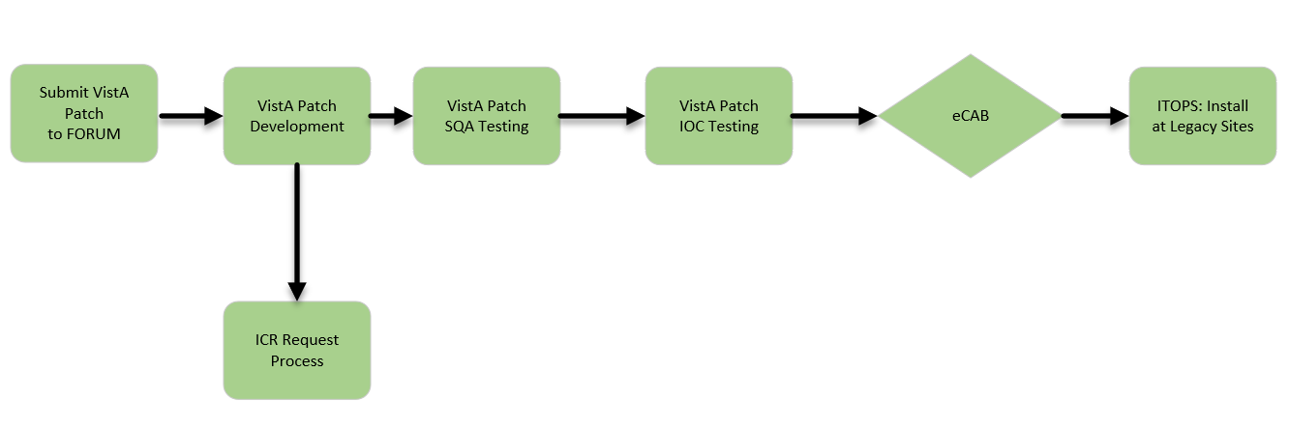

1. VistA Office ICR Process Workflow Overview

This section depicts a simple summary view of the ICR process, as shown in Figure 2.

* Identify existing or create new ICRs in FORUM to support the patch being developed
* Submit ICR Request *
* VO ICR Team reviews initial request *
* Custodian SME reviews the request *
* Final review/approval from Custodian SME *
* VO ICR Team updates FORUM ICR status/subscriber *
* VO ICR Team completes ICR Request

* Outlook message from Intake Form submission used to track history of all communication

Figure 2: VistA Office ICR Process Workflow Overview



1. VistA ICR Request Process

This section describes in detail the steps of the ICR Request Process, shown in Figure 3. Typically, the entire process will take up to 8 weeks.

1. Developer researches the ICR entries in FORUM or using the document located on this page in the ICR Guidance and Useful Information section.​ If there is no existing ICR, the developer enters one into FORUM.
2. Using the ICR number from FORUM, the developer enters an ICR Intake Request Form using the link on the ICR Processes and Standards SharePoint page. Instructions on using this form are also located there.

Upon submission, the developer will receive an email confirmation.  This email will go to the ICR staff and other individuals identified on the form.

1. The ICR team reviews the request.
2. The ICR Team determines if additional information is needed.
3. If more information is needed, the ICR Team contacts the requesting developer.
4. Once all information is gathered, the ICR Team determines who is the Custodial Subject Matter Expert (SME).
5. The ICR Team requests action from the Custodial SME.
6. Custodial SME reviews the request.
7. Custodial SME determines if more information is needed. If more information is needed, the Custodial SME communicates this need to the ICR Team for action.
8. Custodial SME approves the request or recommends alternative action.
9. The ICR Team modifies the ICR is FORUM.
10. The ICR Team informs the developer of the status of the request.
11. The developer verifies action is complete.

The detailed steps the ICR Request Process are shown in Figure 3.

Figure 3: VistA ICR Request Process

